JD Cmments about web

* Lemosho 8 days miss 8 before Lemosho route. Other have like that. (days than name of route)
* All routes have the same rank (four smiles, 75 feedbackcs)

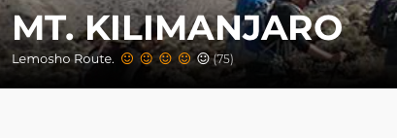

* All routs have the same smiles and ranks

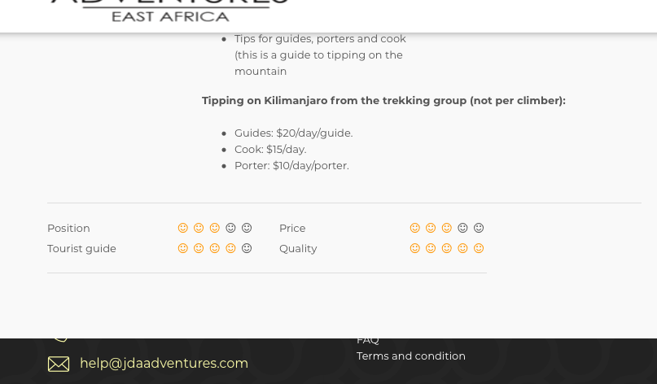

* Still our logo looks bad quality

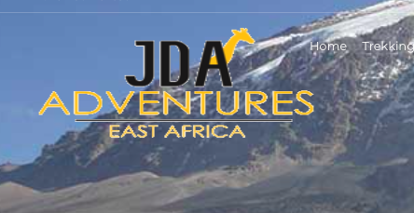

* I think there must have possibiliti when you click on Tracking it opens all routes. Maybe we can change it for now without trekking and leave Mt. Kili, with drop down menu. But still possibility to clik and get to all rout page.

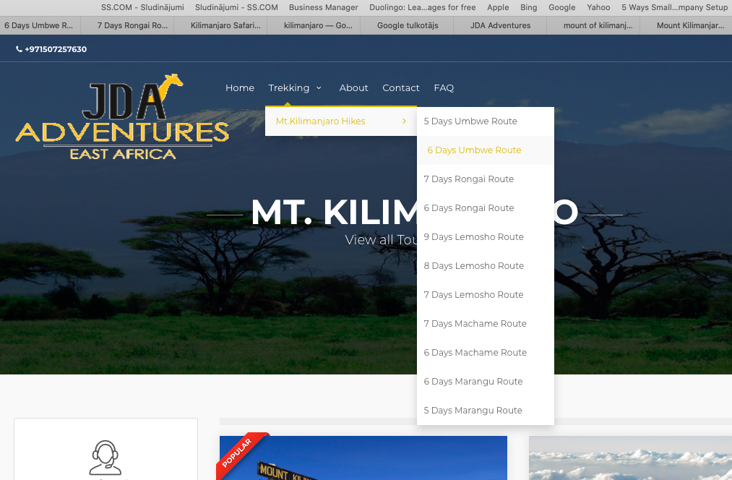

* When open routs, all pictures are the same. We have more photos?

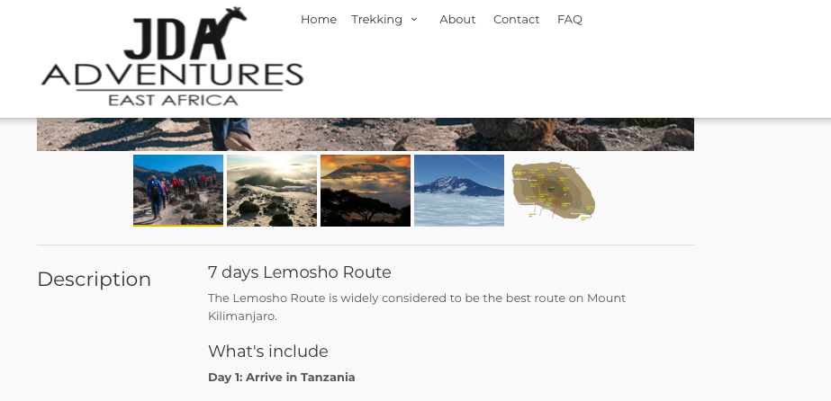

* When I start open first time each menu. It was laging and brand from top bar with drop down menu was moving down.

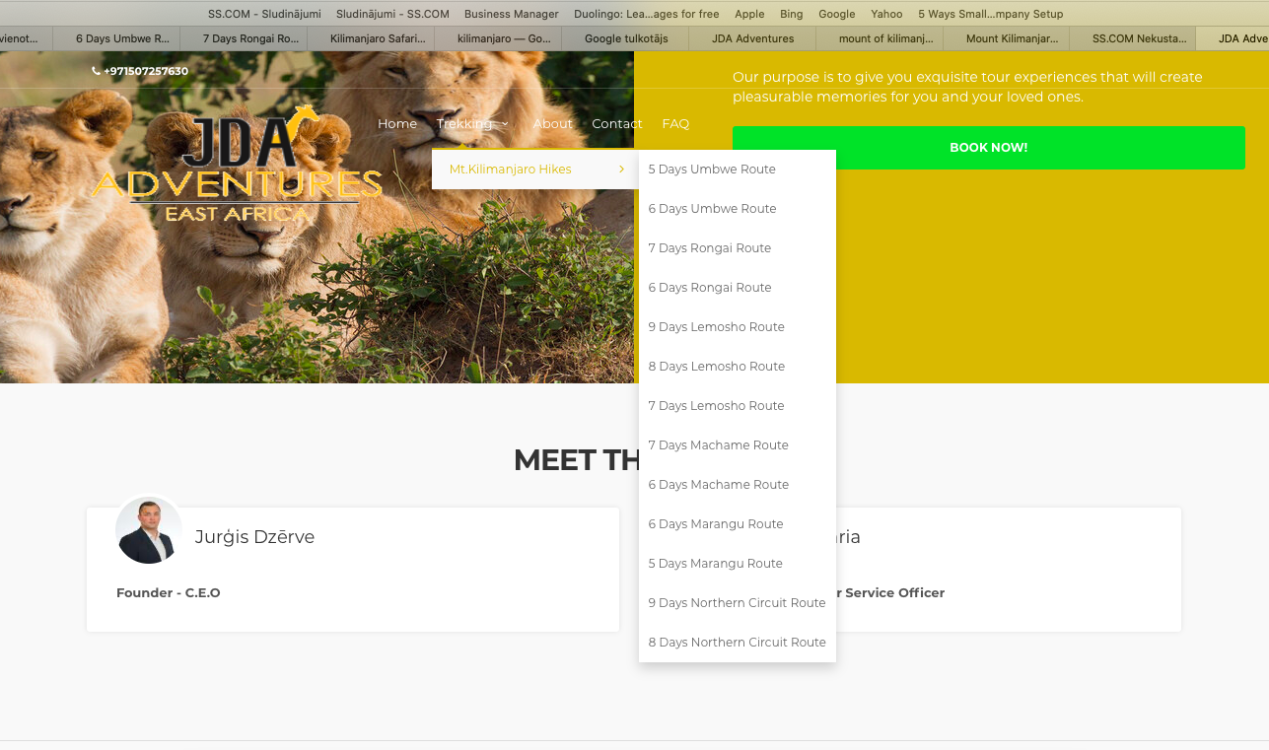

* Can we get this picture even if it’s for money? I wold like it to see on our front page.

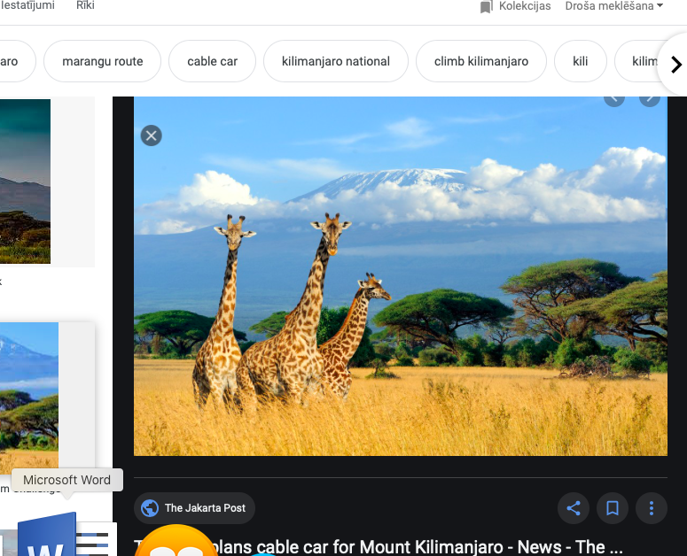

* I thing need to change Contact menu under cover picture

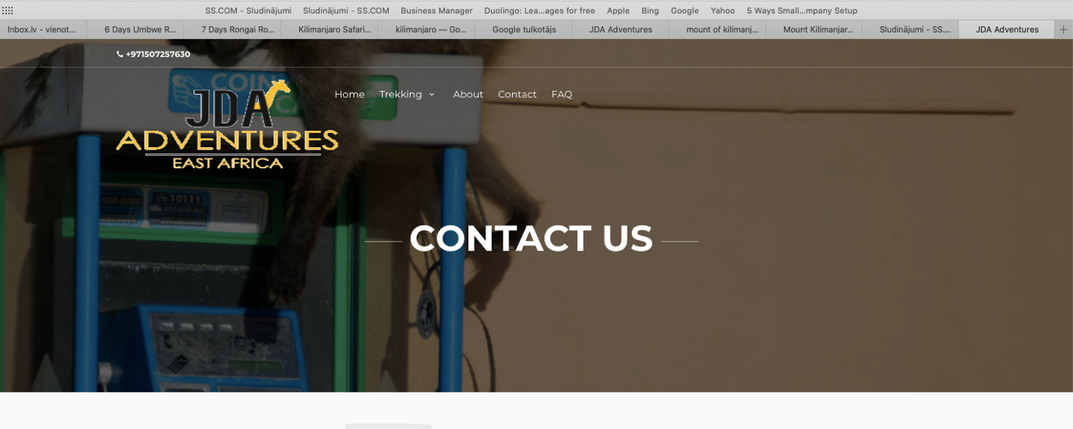

* I think we need to make beter quality for our pictures. (looks bad ☺) As well I like I mentioned we would need to add our personalized company emails

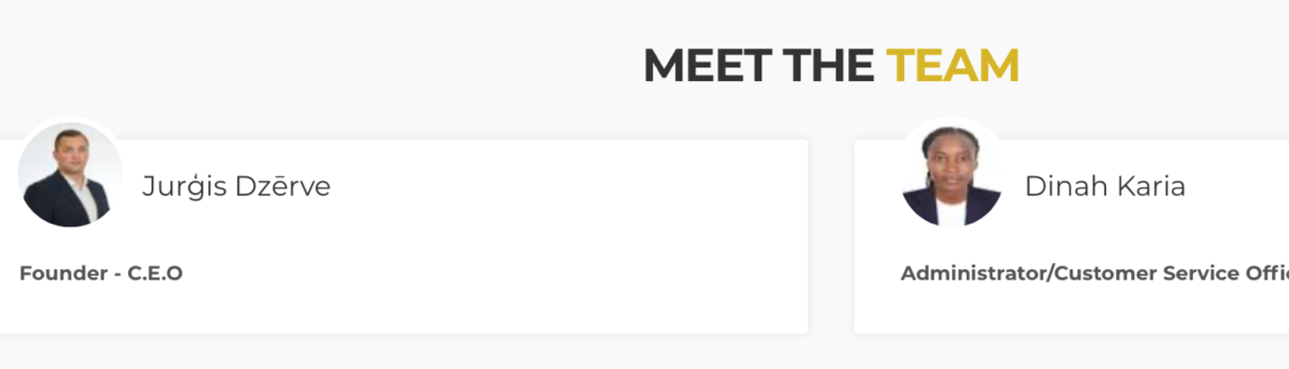

* Need to add + three SOME GOOD REASONS
  + Excellent customer feedback
  + Easy to book
  + Peace of mind guaranty

